Scenario: Your Uncle Bob sends you a link on Facebook to the following tweet about the 2016 election.

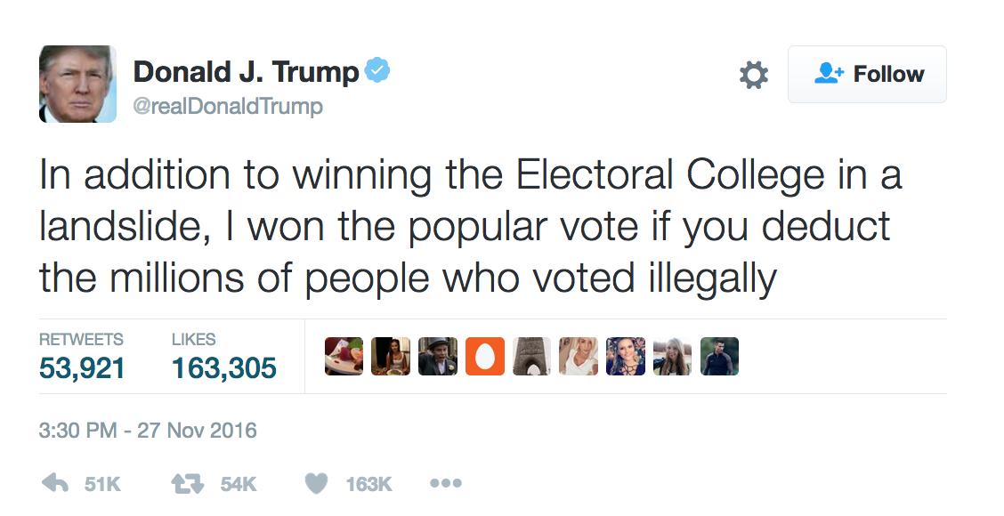

Take a few minutes to describe your initial (and honest) reactions.

- Emotions – How does this story make you feel?

- Values –How does this information fit in with your value system? How are you being influenced by your own values and beliefs? How does this story fit in with Uncle Bob’s values?

- Critical thinking – How does this new information compare to your existing knowledge about the topic? How would you evaluate this information? Please describe the steps you would take to fact check this tweet.

- Reflection – Why do you think Uncle Bob shared this? How might you respond and why?

