Finding Articles
  - How to Select a Database for Your Research
Introduction

Research databases allow users to search for a variety of materials at once, such as scholarly journal articles, popular culture articles, newspapers, and book reviews. Databases may be general or cover a specific topic, for example, business, theology, or visual arts.
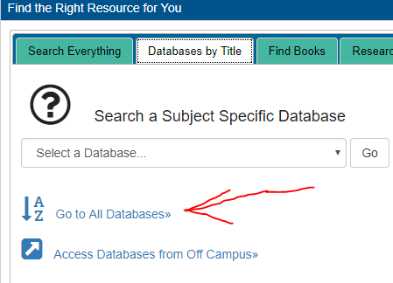
Finding Databases

Go to the Massasoit Libraries webpage (http://library.massasoit.edu/) and click on “Go to All Databases” button the “Databases by Title” tab.

Explore
Browse by subject and select the subject your research topic generally falls under. For example, if your topic is Microsoft, select “Business.”
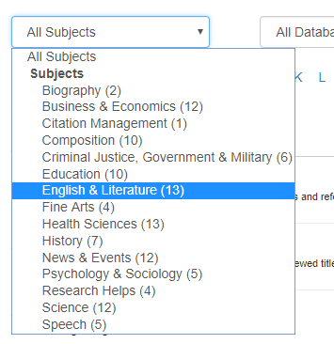

Find Relevant Databases for Your Research Topic
Think about your research topic and the type of sources you need. Read the descriptions of the databases to choose the best ones.
Example: Business Source Premier and Small Business Resource Center provide business sources such as company information, industry profiles, business news, etc.

1. What is your research topic? What type of sources will you need?

List three databases relevant to your research topic. Then analyze each database:
- Does the database provide subject-specific resources? Is there a more focused database?
- What type of sources can you find in the database?
- Does this database allow you to limit your search by date and source type?
- Is this database effective and useful for your research? Why?

Database 1: | Notes:
Database 2: | Notes:
Database 3: | Notes:

Example Research Topic
1. What is the relationship between cell phone use and traffic accidents? What are the implications for banning cell phone use while driving? Sources: news articles, scholarly journal articles, reports

Database: Communication & Mass Media Complete | Notes: Contains over 700 journals on communication and mass media. Yes, this database is subject -specific. This database provides academic journal articles (I can limit by peer-reviewed articles*), trade publications, and magazine articles. Yes, I can limit my search by date and source type. Yes, this database was useful because I found very specific articles on my topic. Yet, I only retrieved 3-5 articles.

*Peer-reviewed articles: Many databases allow you to limit your search by this source type. Peer-review is the process by which an author’s peers, recognized researchers in the field, read and evaluate a paper (article) and recommend whether the paper should be published, revised, or rejected.

