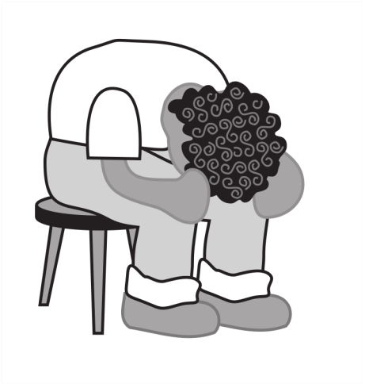
WHAT ARE ALL THESE SOURCES FOR, ANYWAY?
“The Agony of Research”

Getting Started On Evaluating information
Use this worksheet to keep track of the sources you find:
- For each source, write down the title and the name of the publication (if applicable) .
- Identify the type of source it is.
- Evaluate the information need it predominantly fulfills and whether it is scholarly or not.
- Determine the source attribute and check off whether it meets any of the four criteria.

MY TOPIC: ______________________________________________________________
TITLE and PUBLICATION NAME | SOURCE TYPE | INFO NEED ATTRIBUTE NOTES
 | □ Scholarly? | □ Background  □ News  □ Statistics  □ Opinion  □ Research | □ Current  □ Reliable  □ Authoritative  □ Purpose
 | □ Scholarly? | □ Background  □ News  □ Statistics  □ Opinion  □ Research | □ Current  □ Reliable  □ Authoritative  □ Purpose
 | □ Scholarly? | □ Background  □ News  □ Statistics  □ Opinion  □ Research | □ Current  □ Reliable  □ Authoritative  □ Purpose
 | □ Scholarly? | □ Background  □ News  □ Statistics  □ Opinion  □ Research | □ Current  □ Reliable  □ Authoritative  □ Purpose
 | □ Scholarly? | □ Background  □ News  □ Statistics  □ Opinion  □ Research | □ Current  □ Reliable  □ Authoritative  □ Purpose
 | □ Scholarly? | □ Background □ News  □ Statistics  □ Opinion  □ Research | □ Current  □ Reliable  □ Authoritative  □ Purpose
TERMS EXPLAINED

Background: History and definitions.
News: What’s going on recently.
Statistics: Raw data.
Opinion: Reasoned analysis.
Research: Actual, empirical research like surveys or clinical trials.
Current: How timely is it relative to your needs?
Reliable: Is the source generally trustworthy and reliable? Can you identify its biases?
Authoritative: How credible is the author?
Purpose: Why was this published? To inform? To entertain? To persuade? To discover? Etc.

Common Source Types: books, encyclopedias, newspapers, news websites, magazines, essay websites, blogs, social media, government websites, non-profit websites, datasets, scholarly articles,

